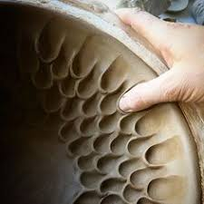
Ceramic Technique Research for Growing up Sculpture (50 points)

For this assignment you will need to go online and find new techniques for decorating ceramic pieces. You must use this technique in your growing up sculpture. Techniques may include: wheel throwing, creating texture, sculpting, attaching, carving, stamping, rolling, glazing or anything else you can use in your sculpture. You use YouTube, Google, Pinterest, or any other site to help you find a ceramic technique. Use three elements of art and principles of design in your presentation.

- You must use this technique in your growing up sculpture.
- Use 3 elements of art and principles of design to describe your technique.
- You will present this technique to the class in a 2-3 minute presentation.
- Present the site where you found the technique.
- Show how you used this technique in your growing up sculpture.

Evaluation will be based on the following 1 being the lowest and 5 being the highest
________ You have a new technique you can present to the class that you found online
________ Your idea is complex and relevant to the class (people might want to use the idea you found).
________ You have used the technique in your “Growing up Sculpture” before your presentation.
________ You are clear and articulate as you present your idea.
________You include three elements of art and principles design and how they apply to your technique.

Elements of art that apply to your technique:
_________________________, _________________________, and _____________________________.

